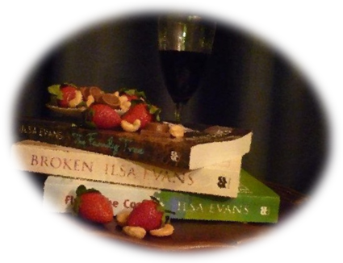

The rules are simple (mainly because there aren’t many!) – just send in your opinion/review of a traditionally-published book written by an Australian female author. Positive, negative, neutral – whatever floats your boat. Enter as many times as you like. Three entries will win a prize pack of four (Ilsa Evans) books and they, along with a selection of about twenty others, will be included in a pre-Christmas newsletter. Which will hopefully give us all some terrific gift ideas, while doing our bit for the book industry and women writers at the same time. It’s a win-win (win) situation!
Name:

Circle your preference for newsletter: FULL NAME FIRST NAME ONLY ANONYMOUS

Email address:

(for correspondence only – not for the newsletter)

Name of author:
Name of book:

Review/opinion (just a couple of lines - around 50 words)

Email entries (and any enquiries) to ilsa@ilsaevans.com
Competition closes on 14th October 2011 (the birthday of Miles Franklin!)

